### UNEARTHING THE ENVIRONMENTAL IMPACT OF HUMAN ACTIVITY: A GLOBAL CO2 EMISSION ANALYSIS

# INTRODUCTION

1.1OVERVIEW

A BRIEF DESCRIPTION ABOUT YOUR PROJECT

* 1. 1.2PURPOSE

CO2 WHAT CAN BE ACHIEVED USING THIS.

1. **PROBLEM DEFINITION & DESIGN THINKING**

2.1EMPATHY MAP

PASTE THE EMPATHY MAP SCREENSHOT

2.2IDEATION & BRAINSTORMING MAP

PASTE THE IDEATION & BRAINSTORMING MAP SCREENSHOT

# RESULT

FINAL FINDINGS (OUTPUT) OF THE PROJECT ALONG WITH SCREENSHOTS.

# ADVANTAGES & DISADVANTAGES

LIST OF ADVANTAGES AND DISADVANTAGES OF THE PROPOSED SOLUTION

# APPLICATIONS

THE AREAS WHERE THIS SOLUTION CAN BE APPLIED

# CONCLUSION

CONCLUSION SUMMARIZING THE ENTIRE WORK AND FINDINGS.

# FUTURE SCOPE

ENHANCEMENTS THAT CAN BE MADE IN THE FUTURE.

# APPENDIX

A. SOURCE CODE

**1 INTRODUCTION**

**1.1OVERVIEW**

PROJECT DESCRIPTION

Global warming is one of the biggest challenges currently being faced by the human race, although correlation is not causation, a likely cause of global warming is due to increased atmospheric carbon dioxide from human activities. CO2 **emission** refers to the carbon dioxide emitted throughout the world. For this analysis we will be focusing on CO2 emissions and its effect on the world we live in as well as some key factors and stats that may play a role in the emission of CO2 globally. Fossil fuel use is the primary source of CO2. The data throws light onto how much fossil fuels are burnt, per year per nation, which amounts to an increase in CO2 every year. This will help researchers and environment experts to predict global warming. So countries should set a goal to decrease this amount yearly.

Analyzing global CO2 emission across countries from 1975 to 2020. This dataset contains a record of CO2 emission by each country and region of earth, here we are going to analyze and visualize country wise, region wise and overall CO2 emission on earth.

**1.2 PURPOSE**

The purpose of this project is to analyze global CO2 emission across countries from 1975 to 2020. This dataset contains a record of CO2 emission by each country and region of earth, here we are going to analyze and visualize country wise, region wise and overall CO2 emission on earth.

**2 PROBLEM DEFINITIONS AND DESIGN THINKING**

**2.1EMPATHY MAP**

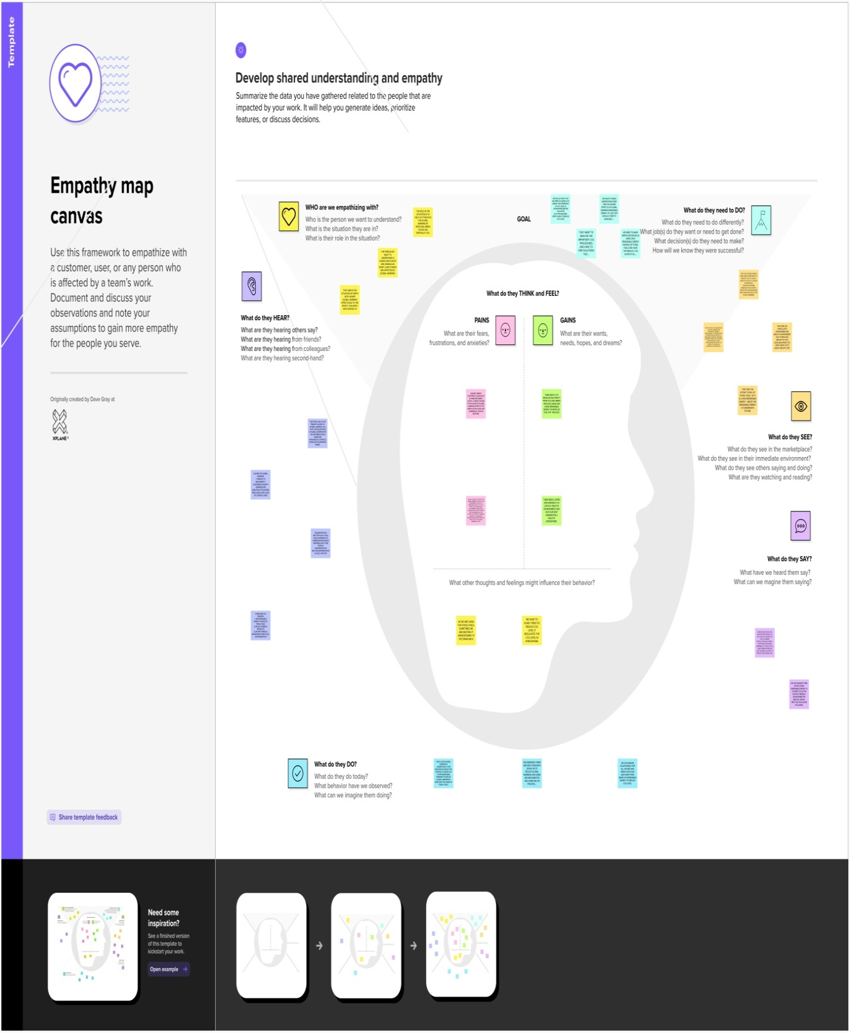

**2.2IDEATION AND BRAINSTORMING MAP**

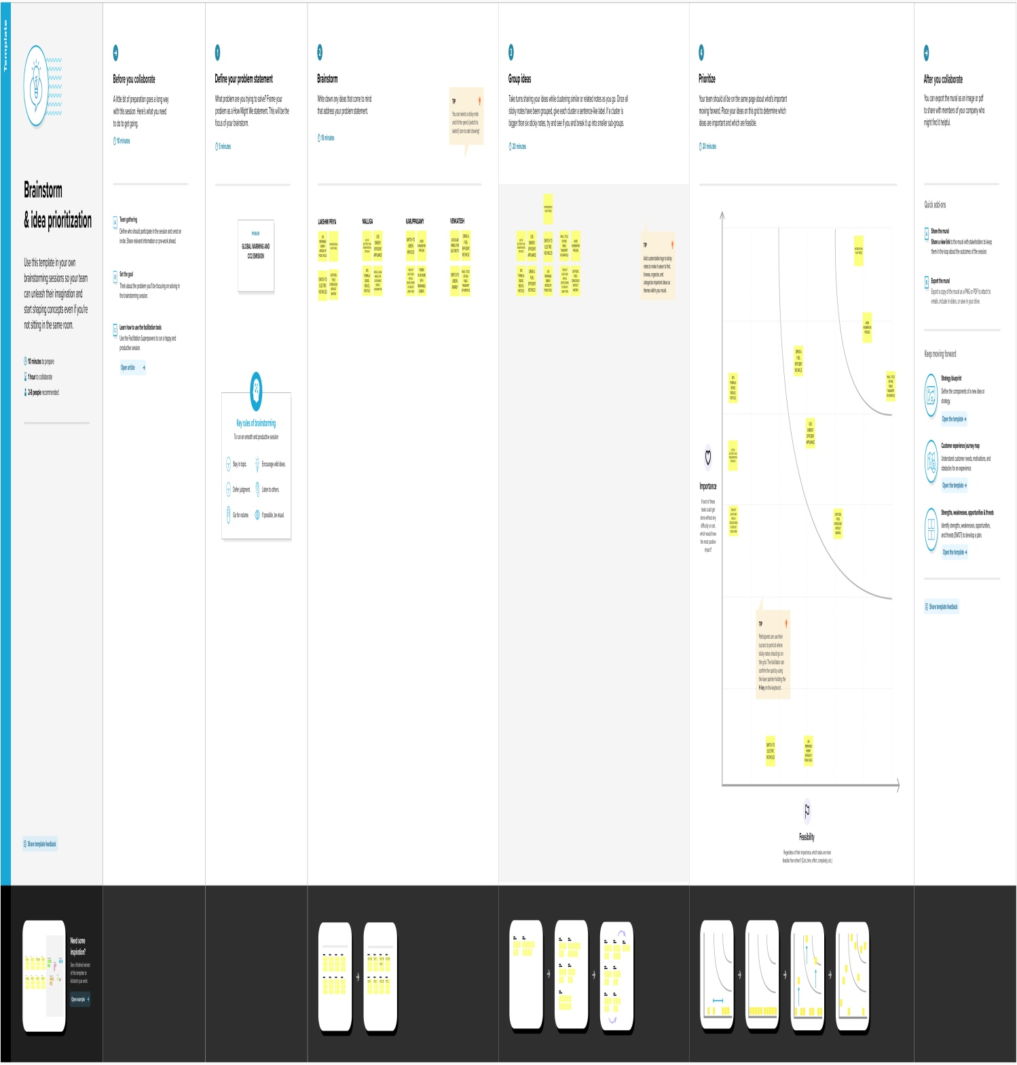

**3 RESULTS**

Sheets are created using tableau with given data set, the dashboards and stories are created using the worksheets. We have published our dashboard and story file in tableau public.

The sheets are

**1. TOTAL WORLD EMISSION**

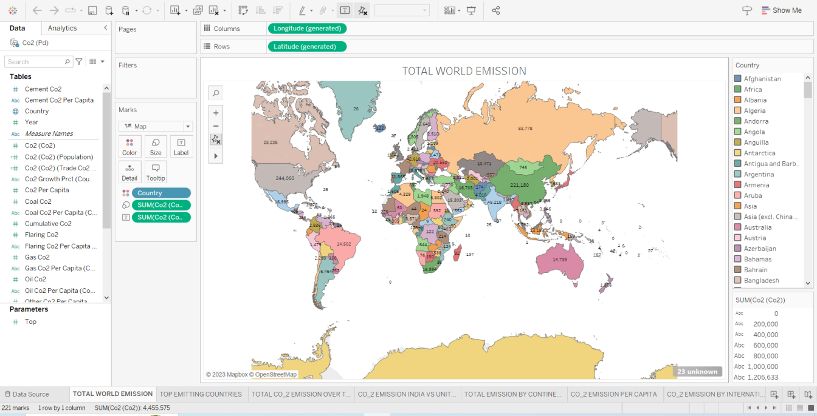

**2. TOP EMITTING COUNTRIES**

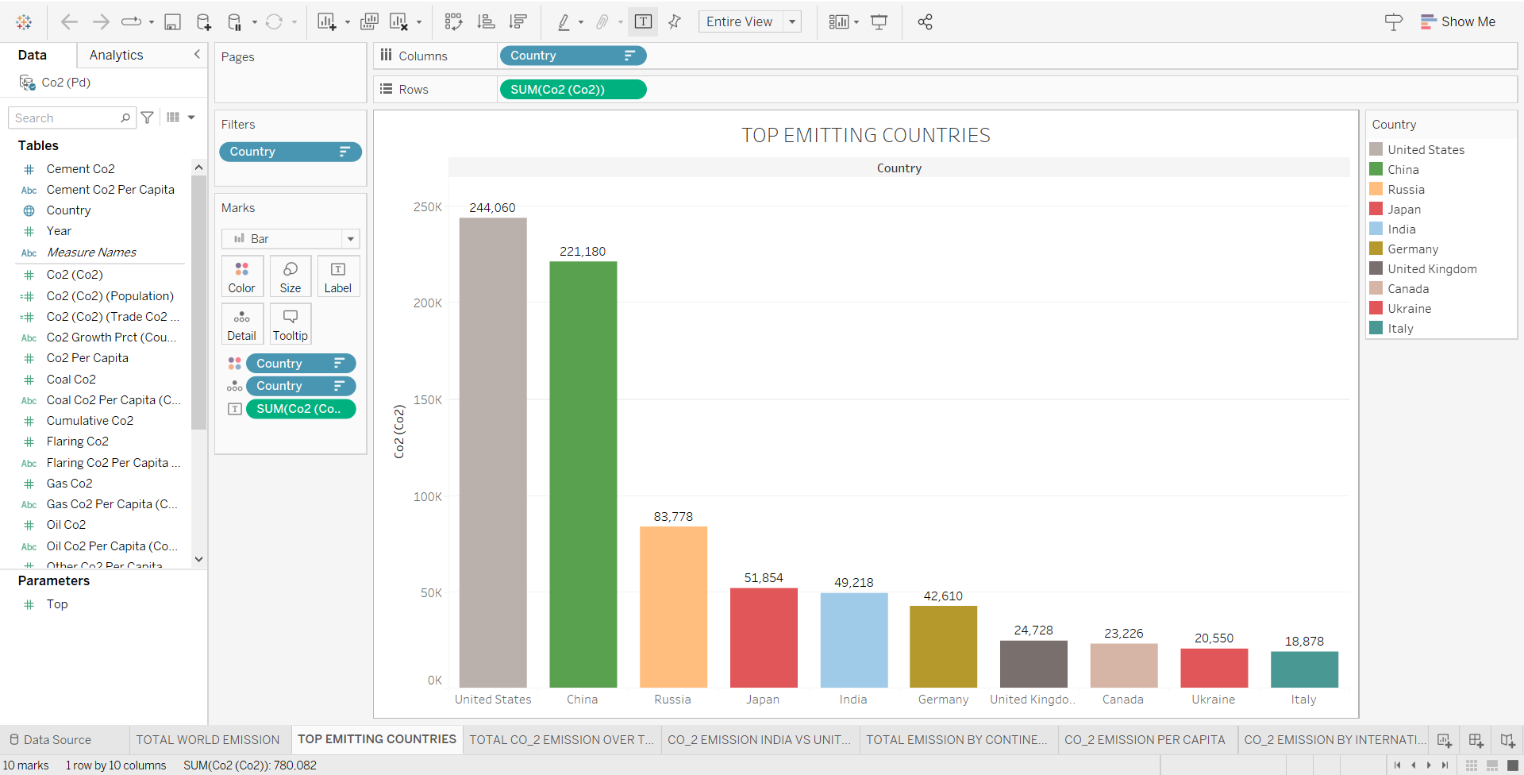

**3. TOTAL CO_2 EMISSION OVER TIME**

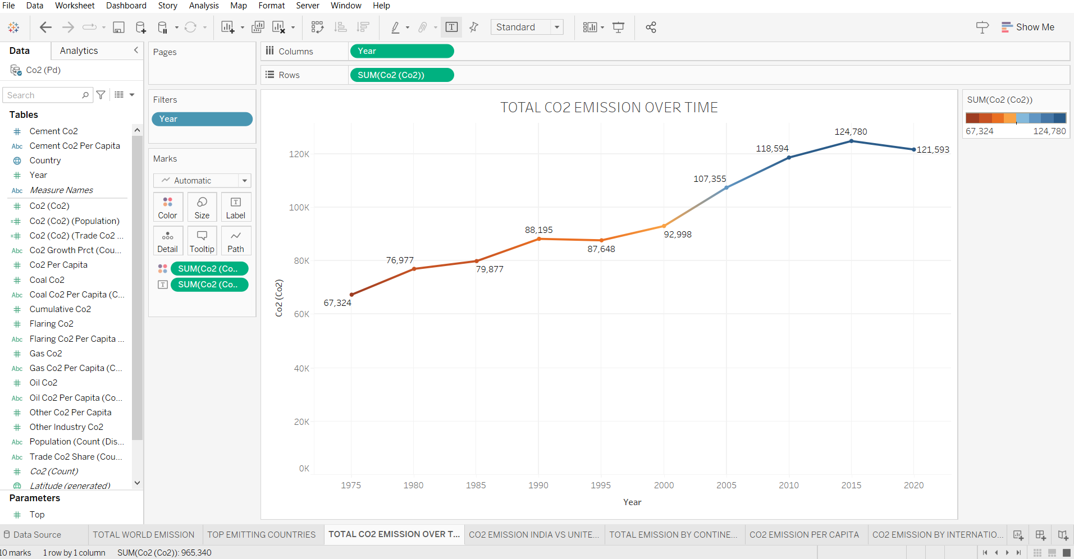

**4. CO2 EMISSION INDIA VS UNITED STATES**

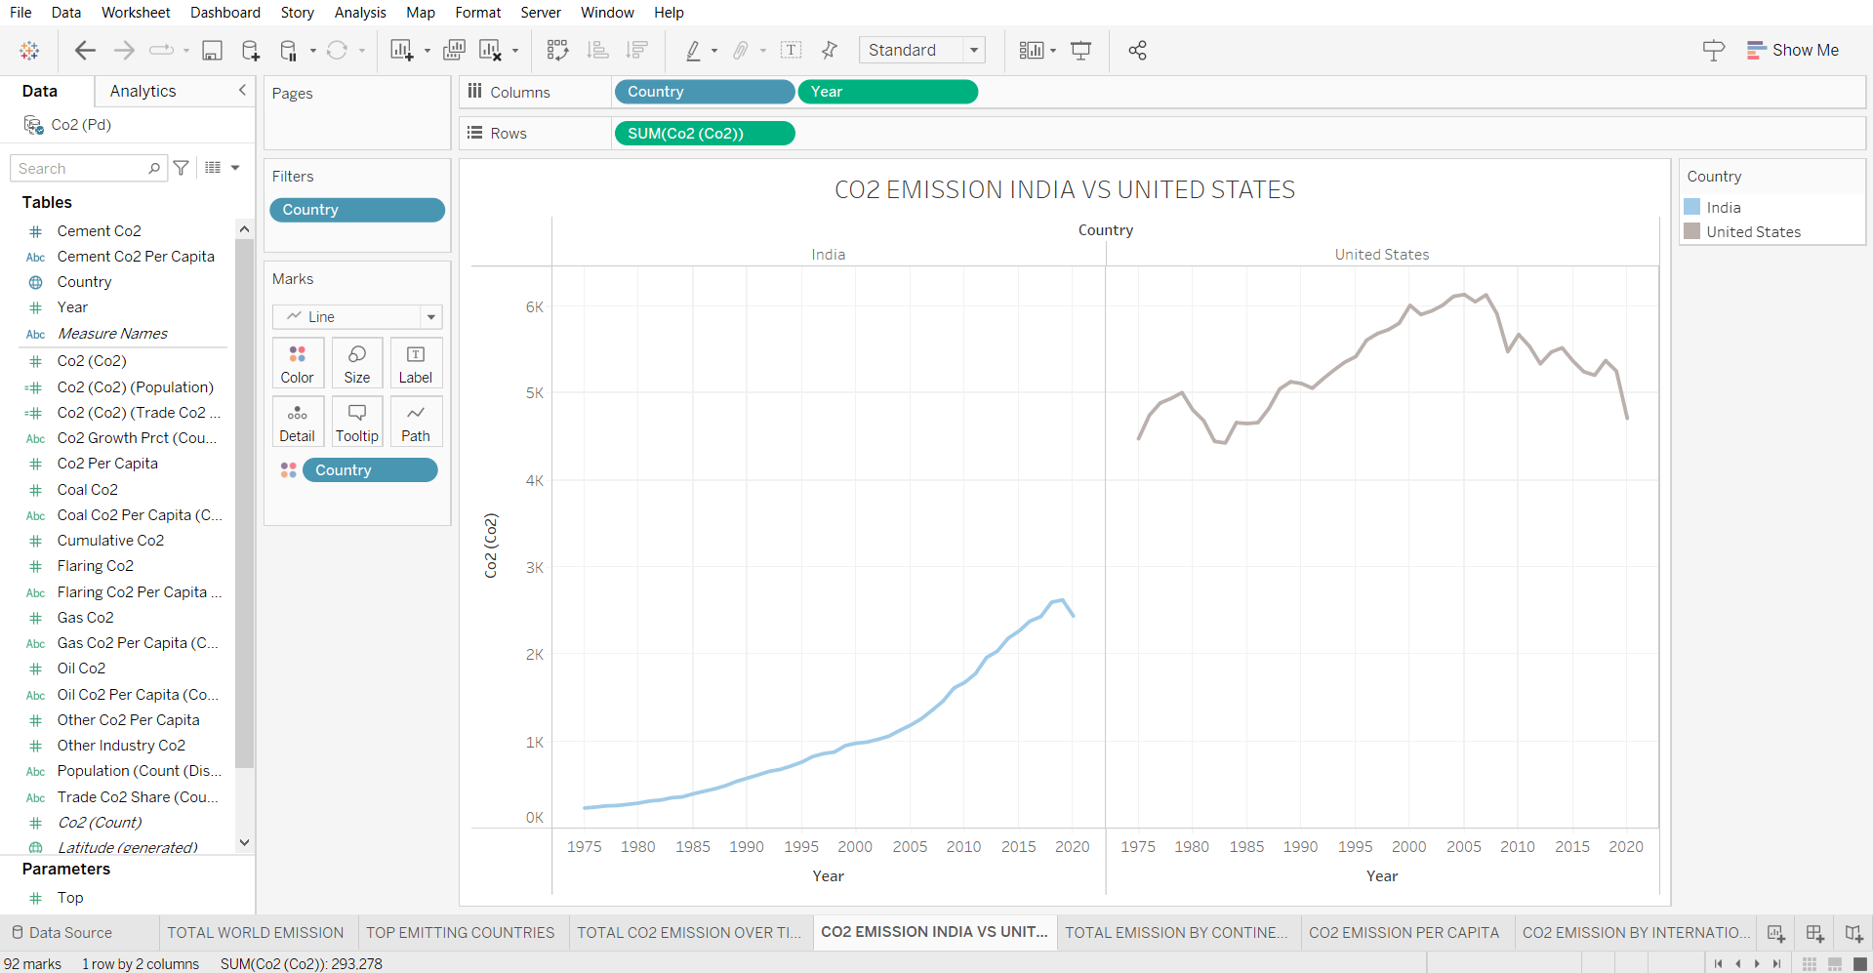

**5. TOTAL EMISSION BY CONTINENTS**

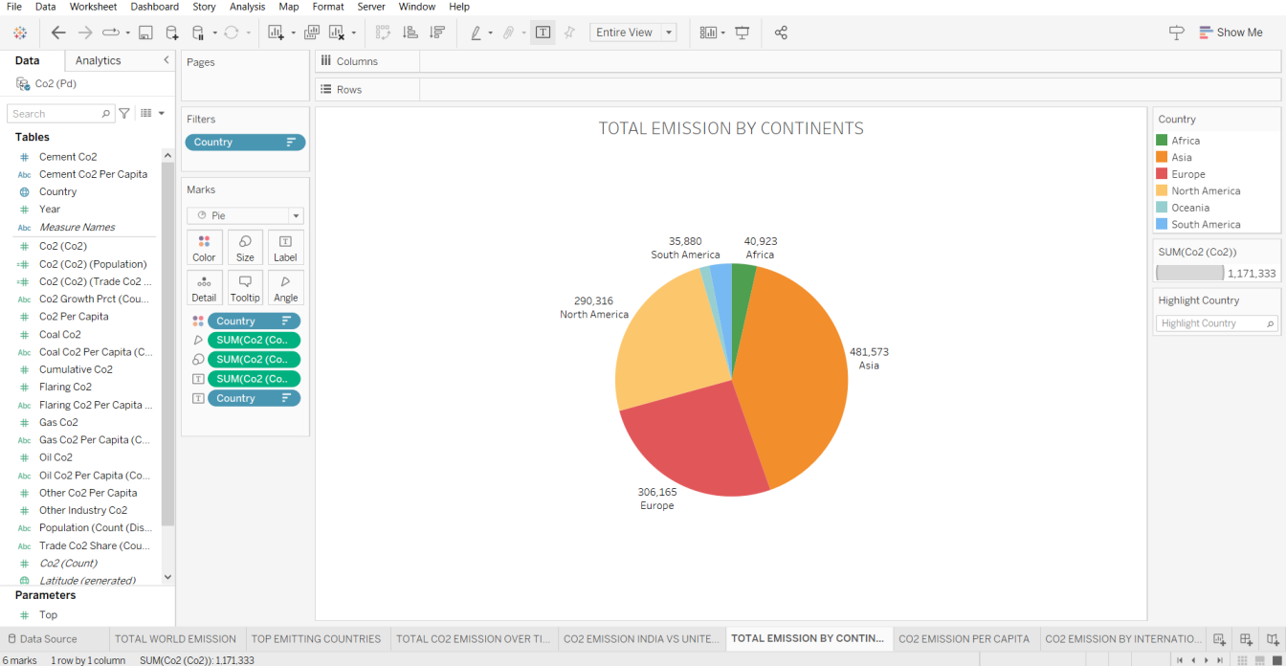

**6. CO_2 EMISSION PER CAPITA**

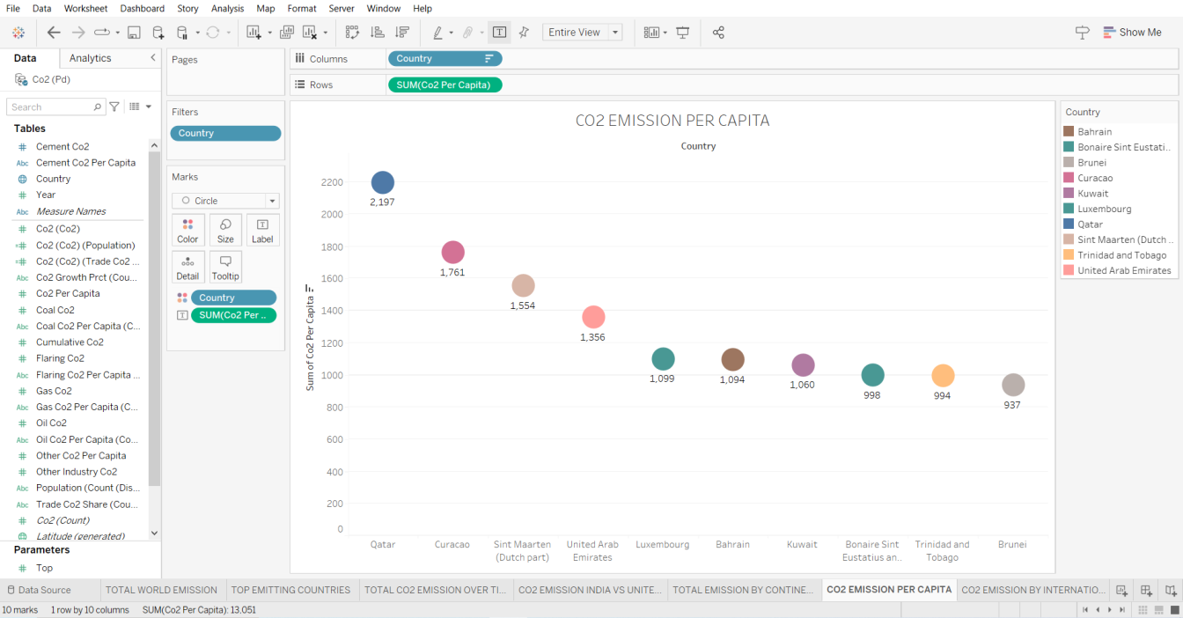

**7. CO2 EMISSION BY INTERNAL FACTORS**

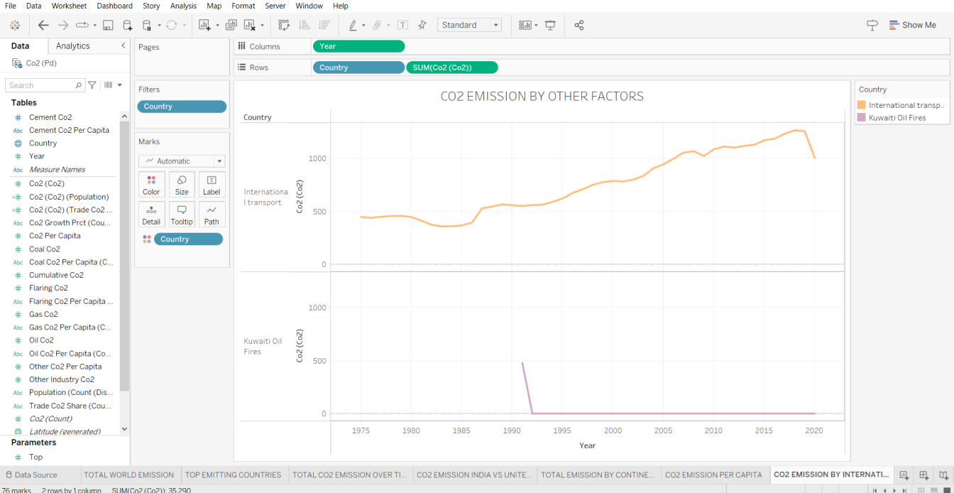

**8. EMISSION RATE BY INTERNAL FACTORS**

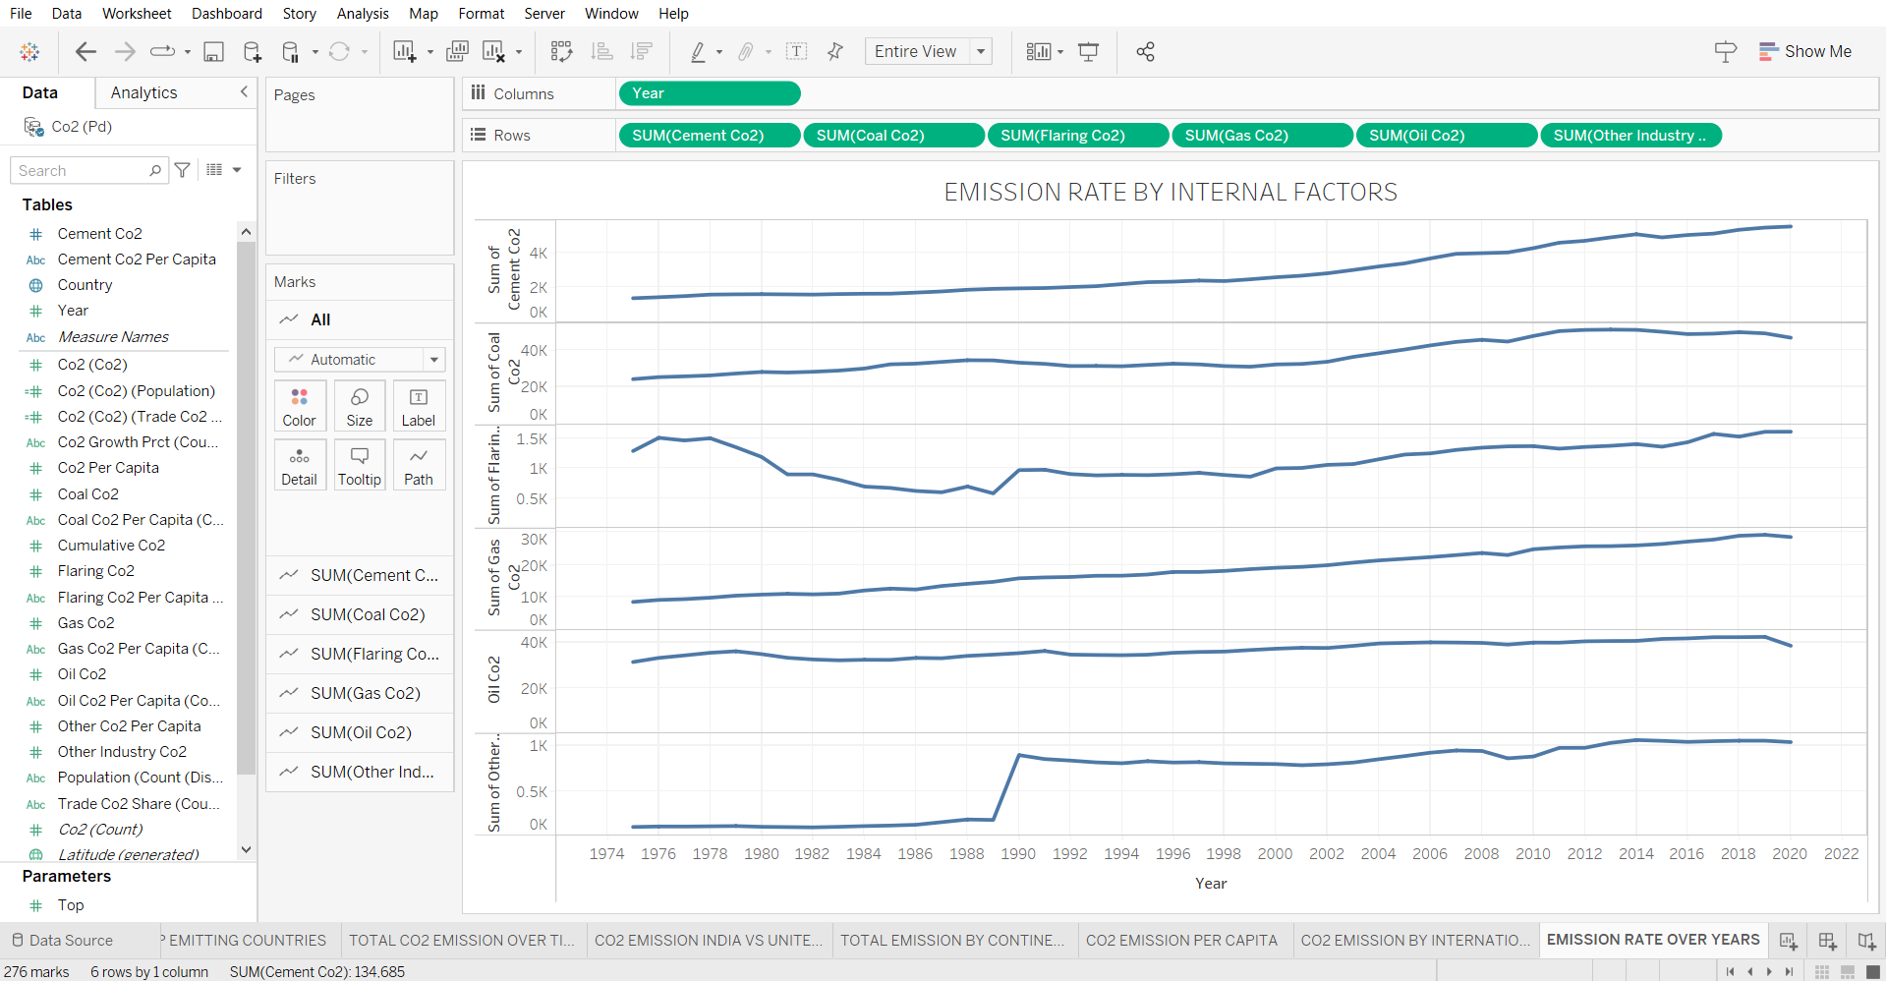

**9. DONUT CHART FOR COAL CO_2**

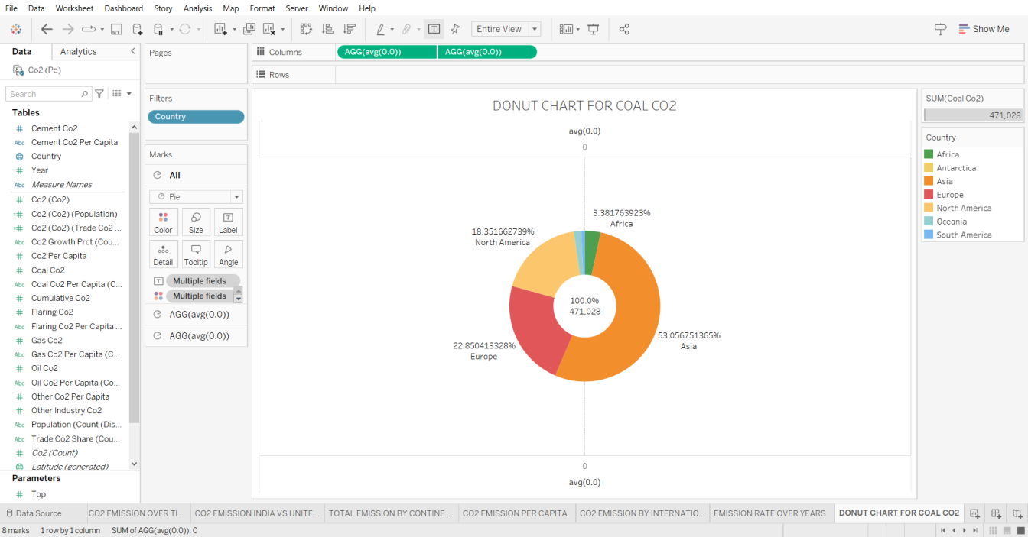

**10. DONUT CHART FOR CEMENT CO2 EMISSION**

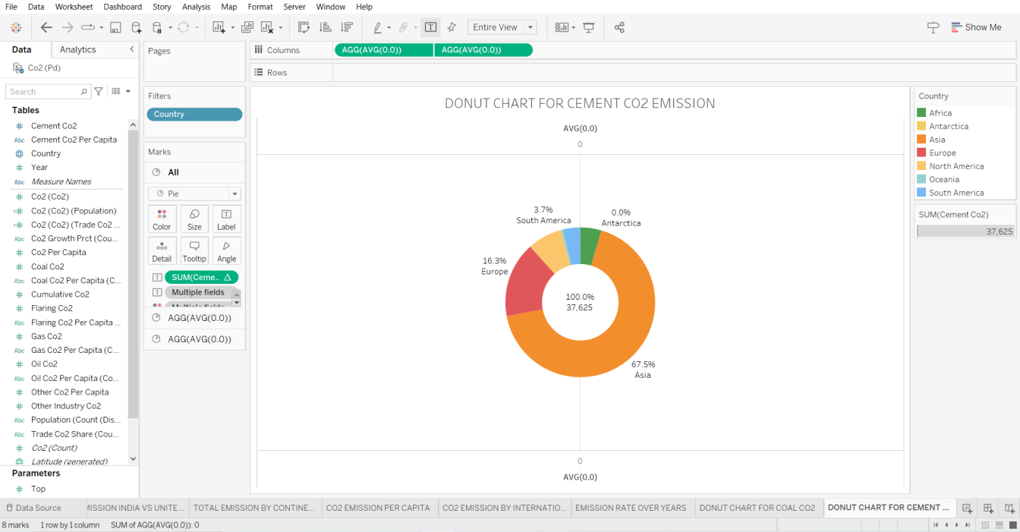

**11. DONUT CHART FOR GAS CO2**

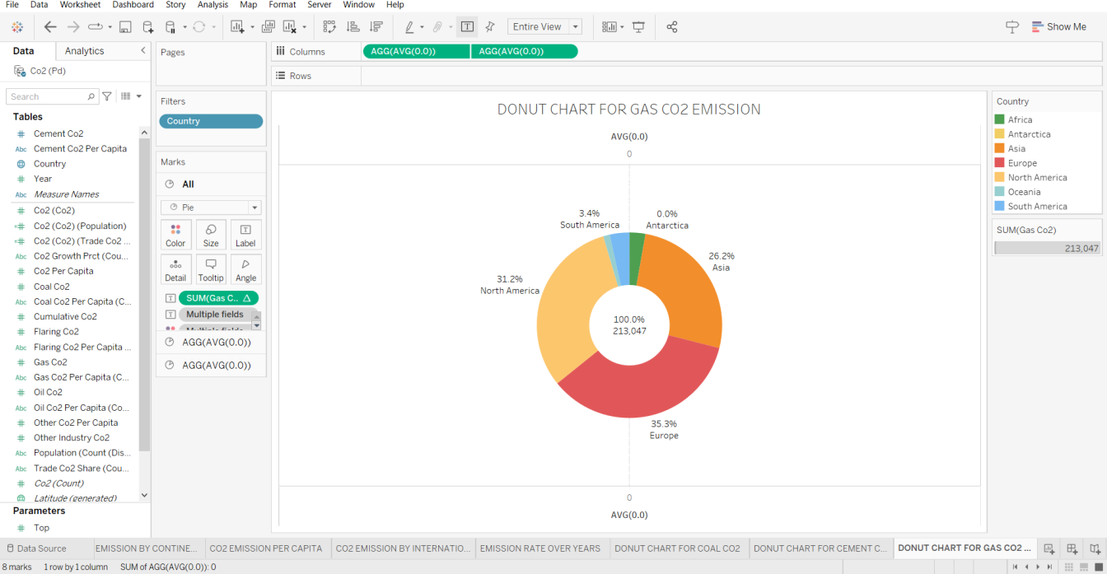

**12. DONUT CHART FOR FLARING CO2 EMISSION**

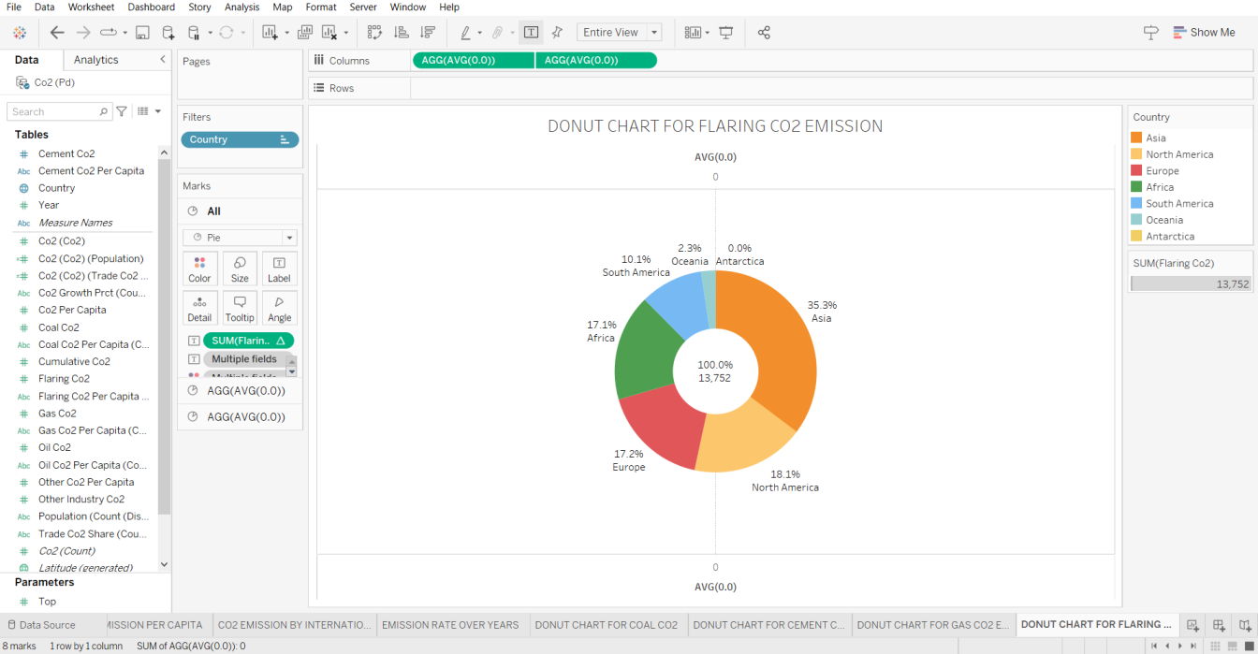

**13. DONUT CHART FOR OIL CO2 EMISSION**

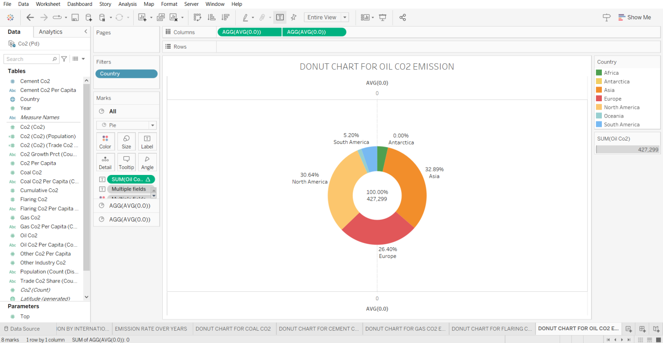

**14. CO2 EMISSION OVER PAST 10 YEARS**

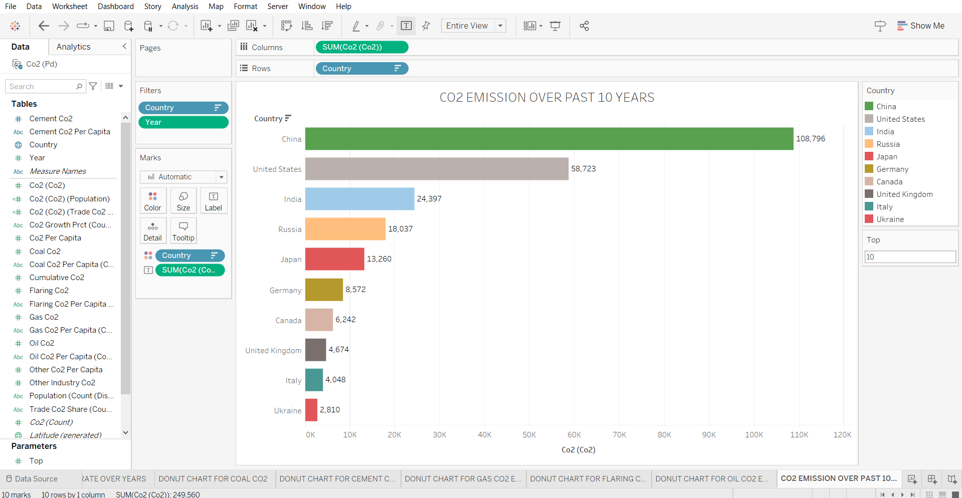

**15. OVERALL CONTRIBUTION BY INDIA IN CO2 EMISSION**

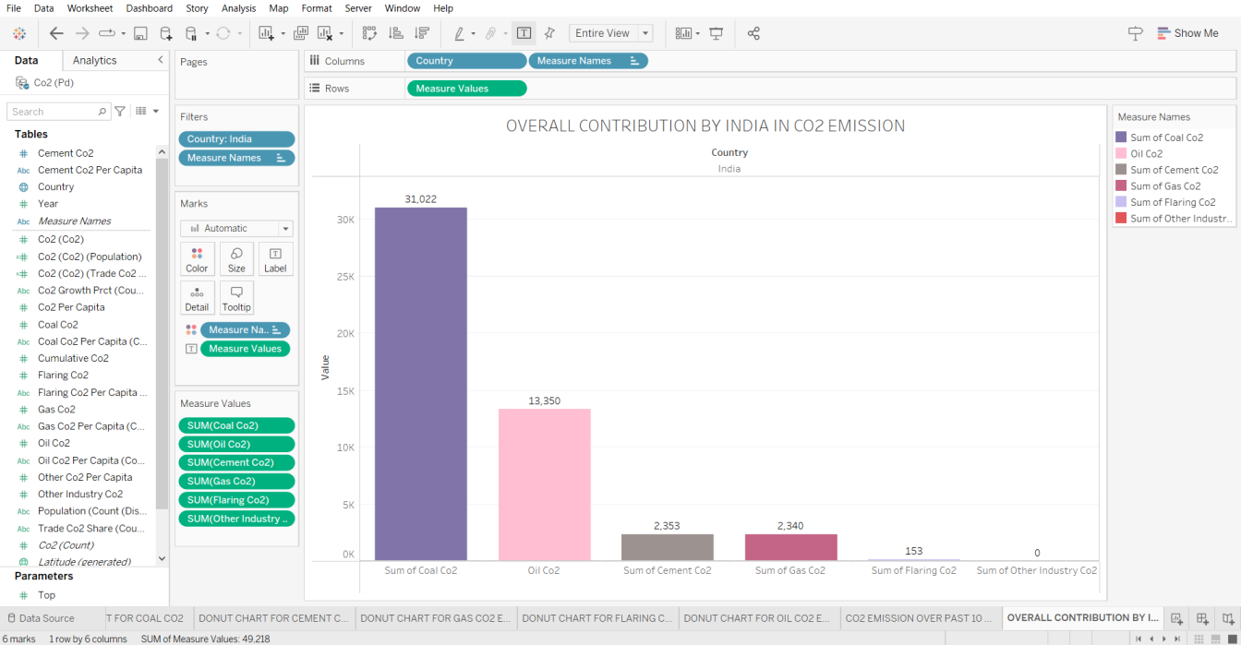

**16. CONTINENT WISE CONTRIBUTION BY INTERNAL FACTORS**

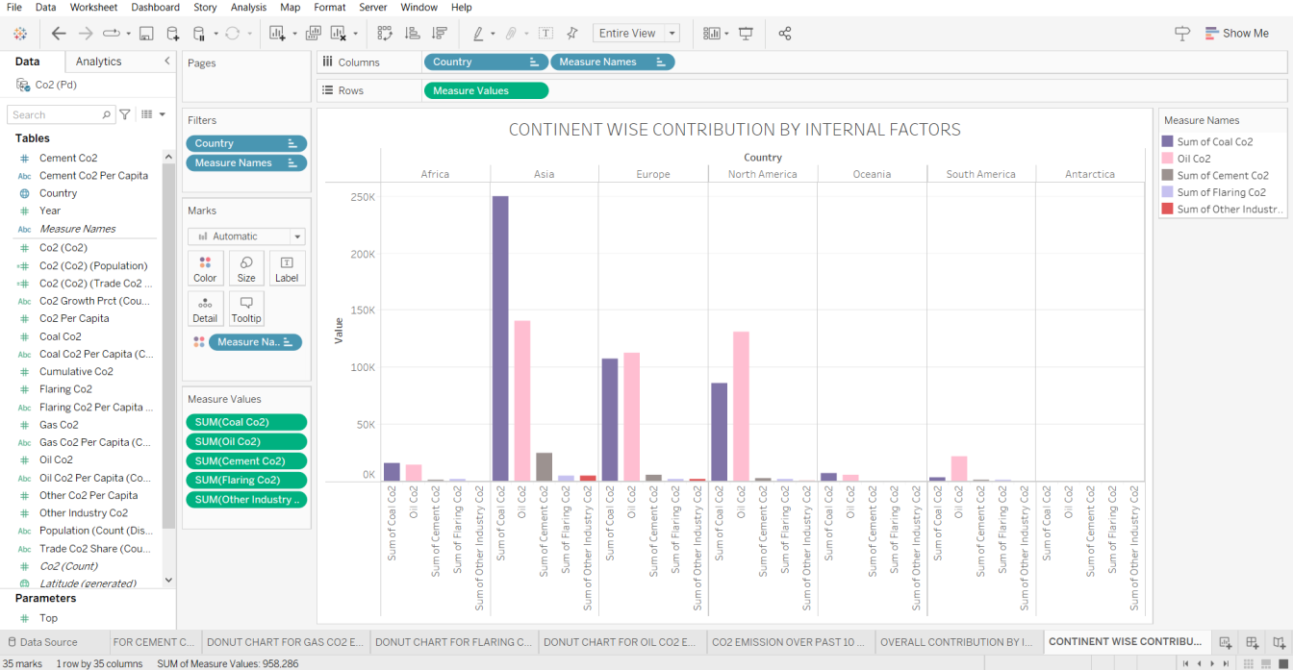

**17. CO2 EMISSION FROM 1990 TO 2020 BASED ON INTERNAL FACTORS**

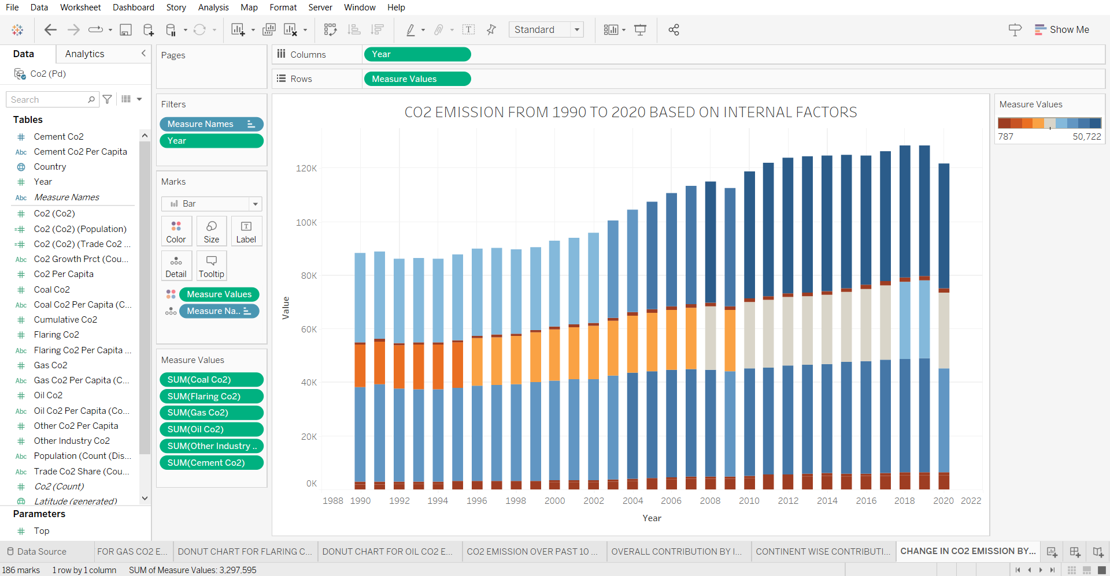

**18. CUMMULATIVE CO2 AND CO2 PER CAPITA OVER YEARS**

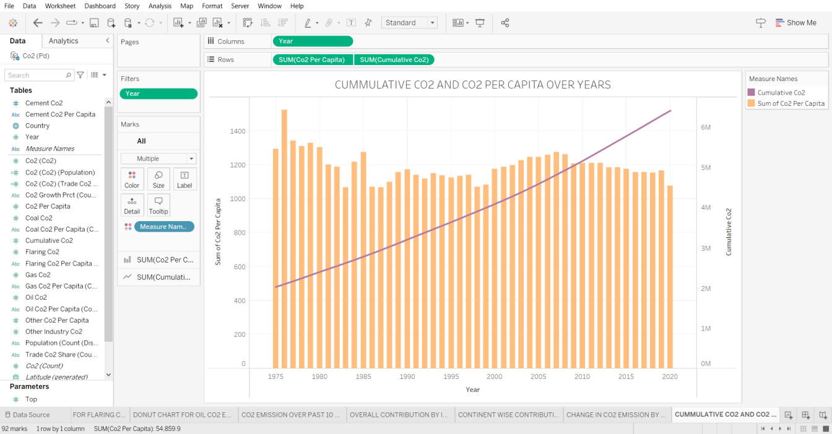

**19. CO2 EMISSION IN 2020**

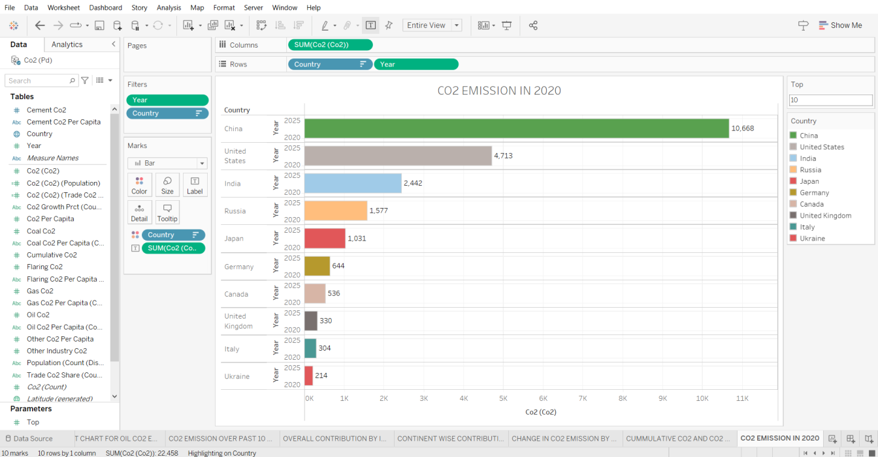

**20. CHINA VS INDIA INTERNAL FACTORS**

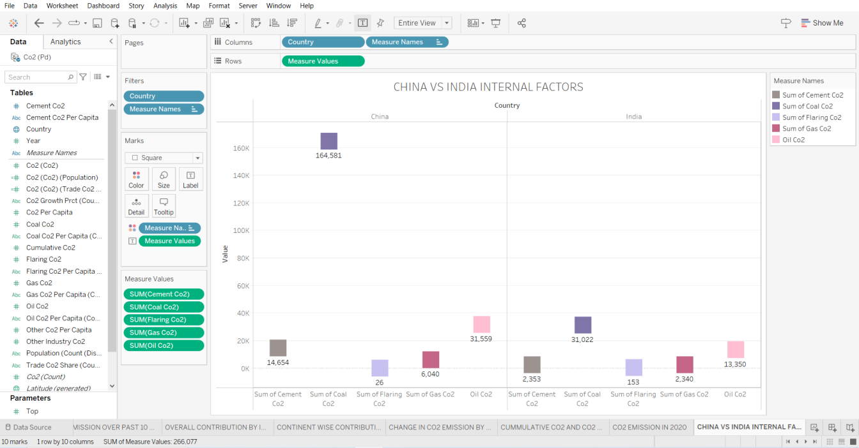

**21. OVERALL CONTRIBUTION BY CHINA IN CO2 EMISSION**

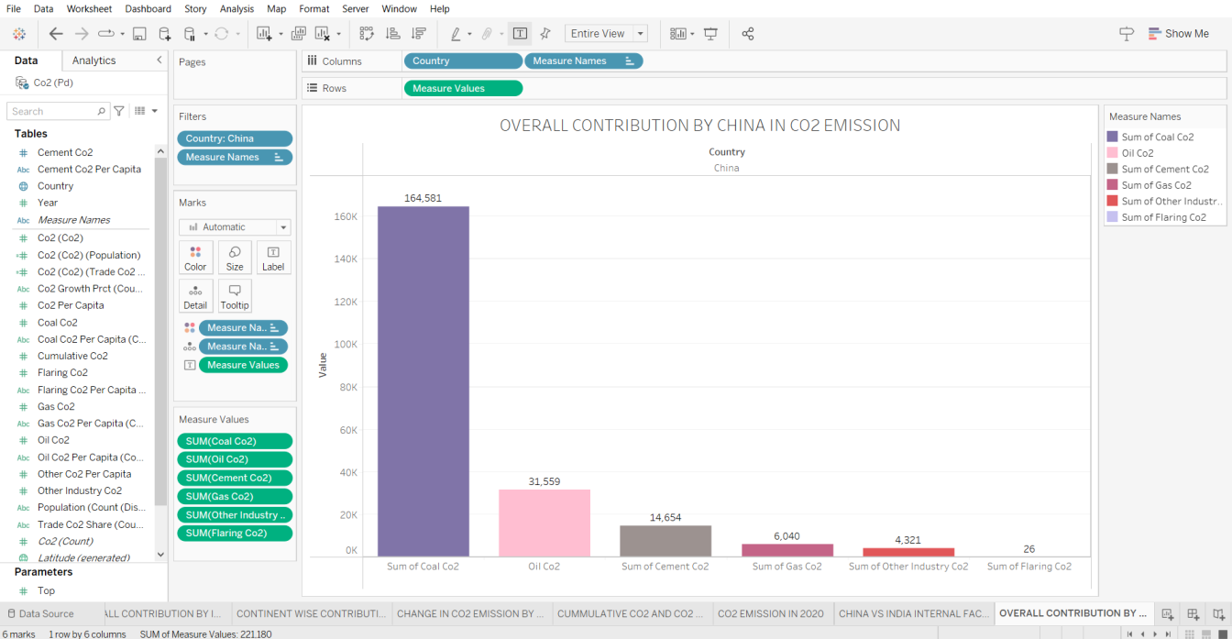

The dashboards are

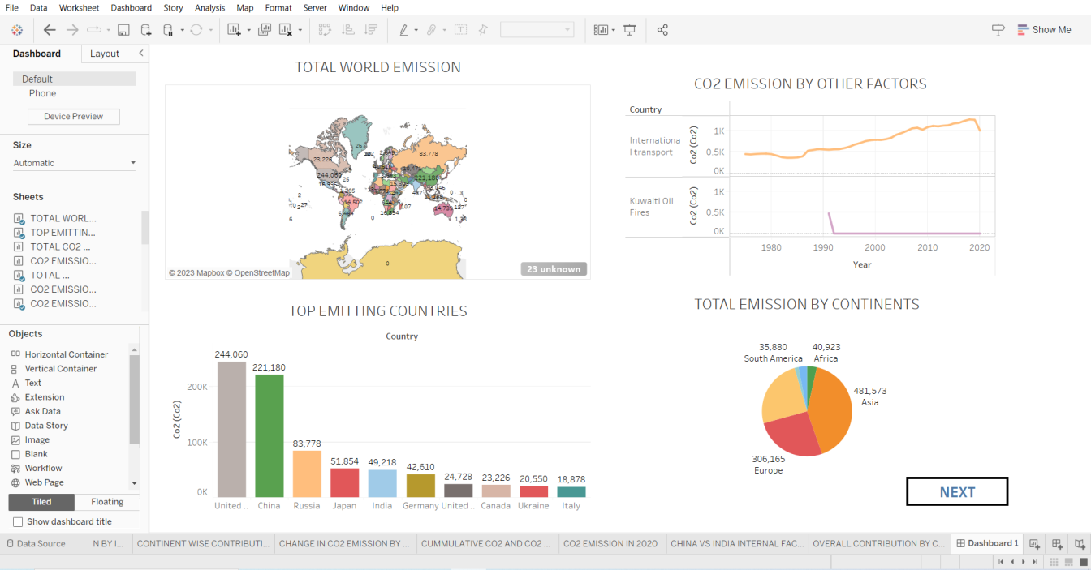

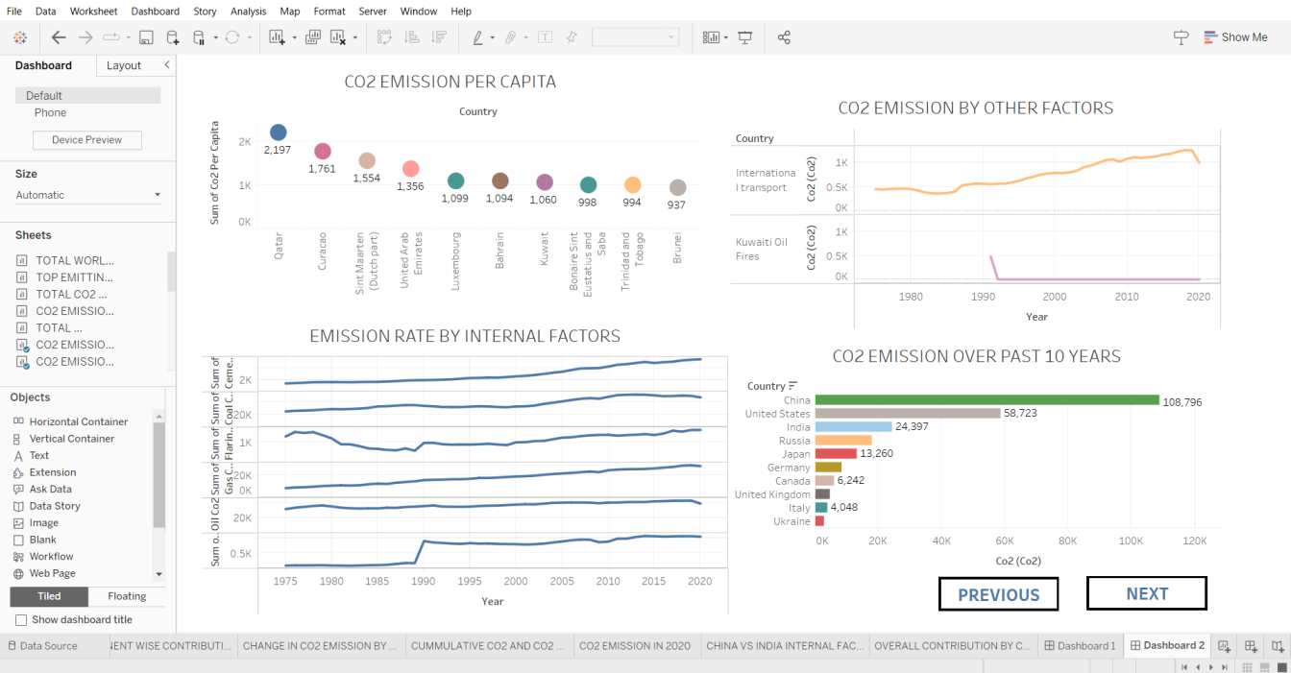

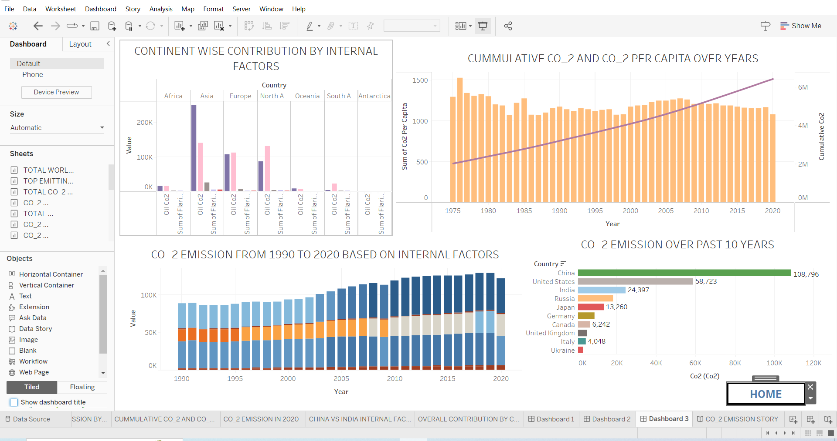

The Story is

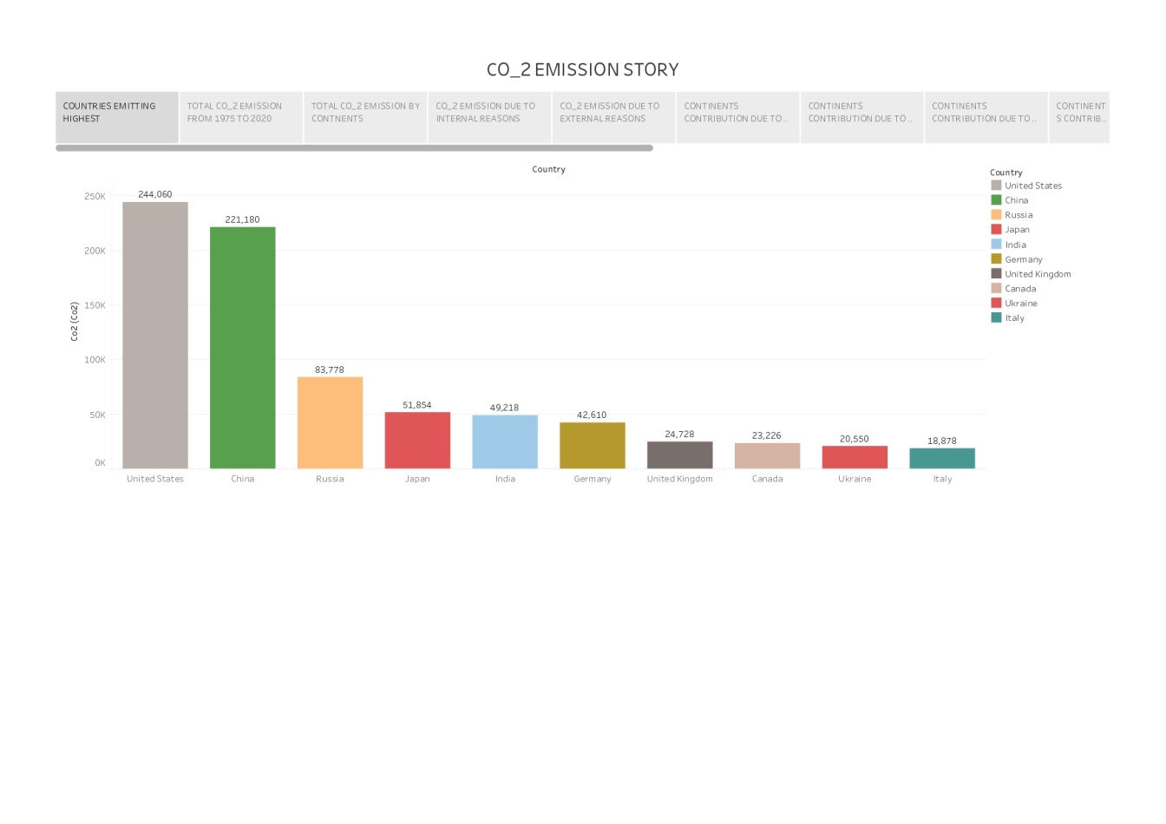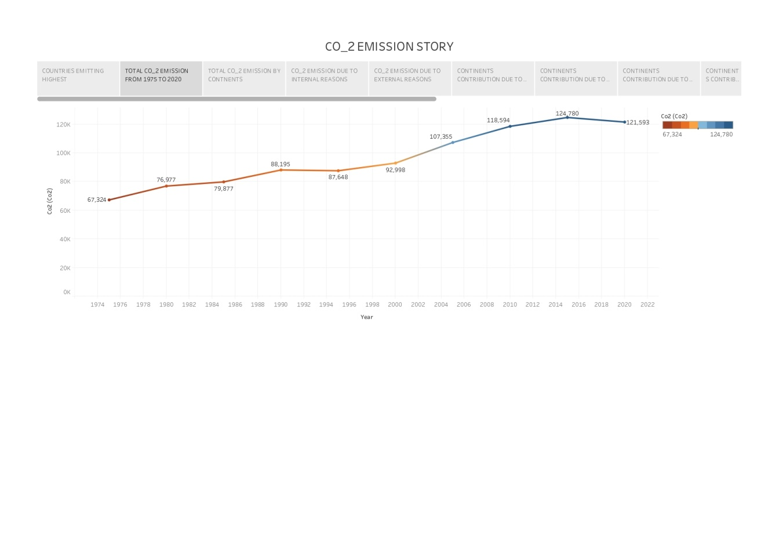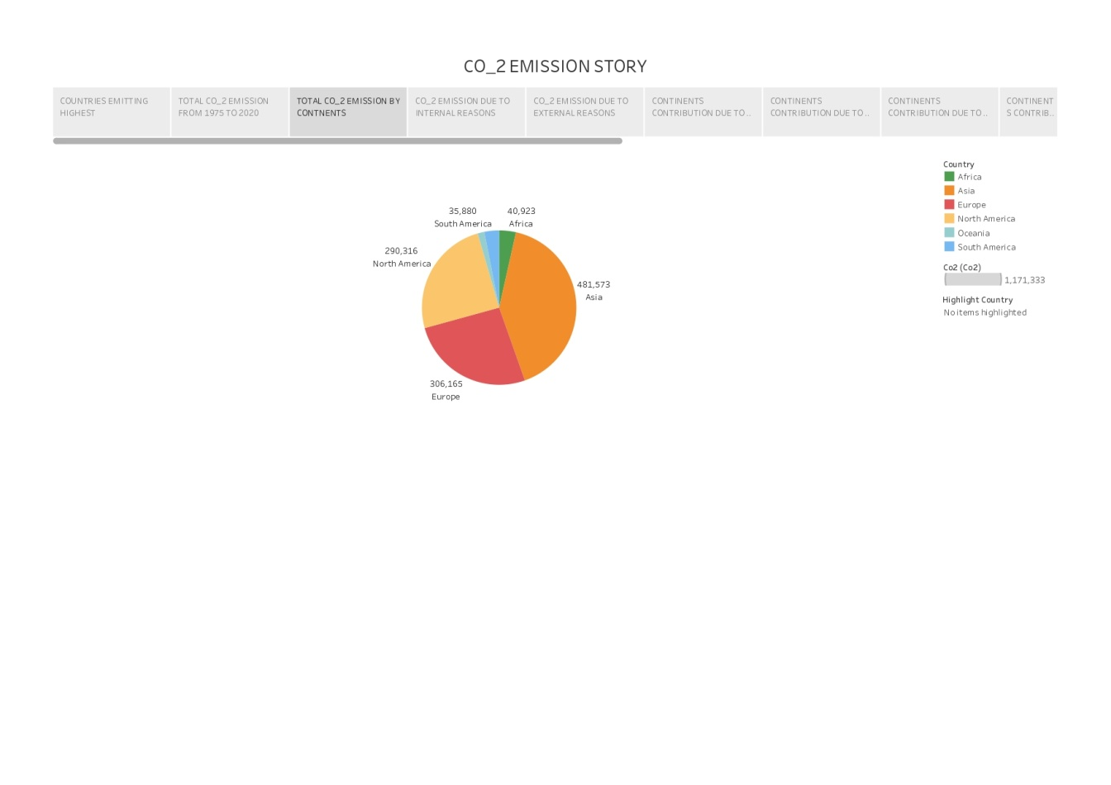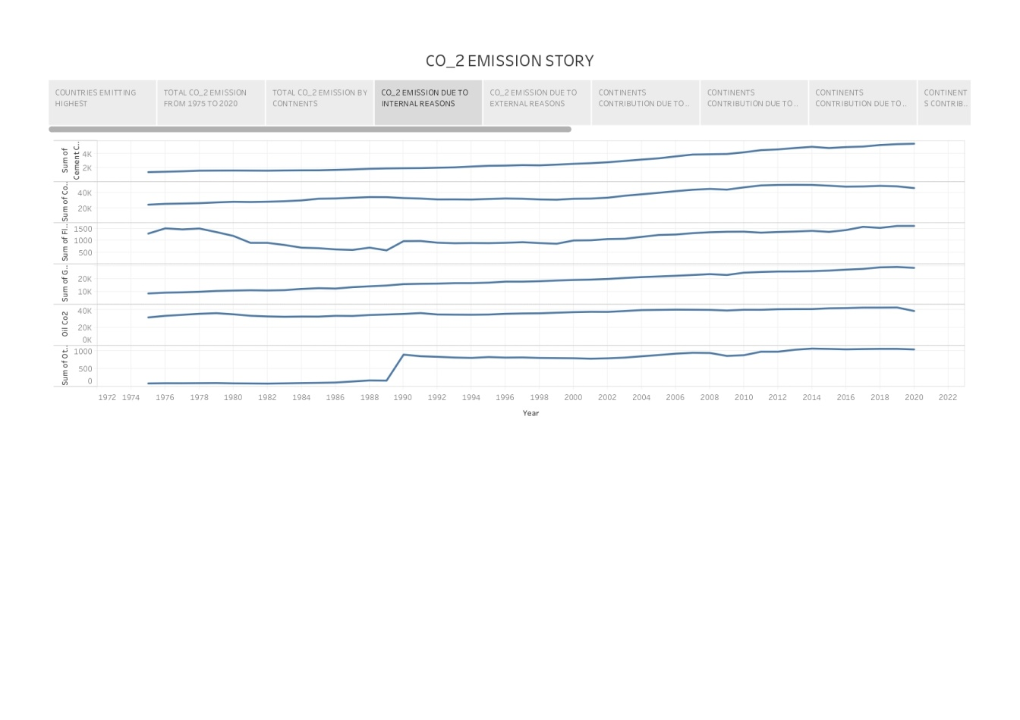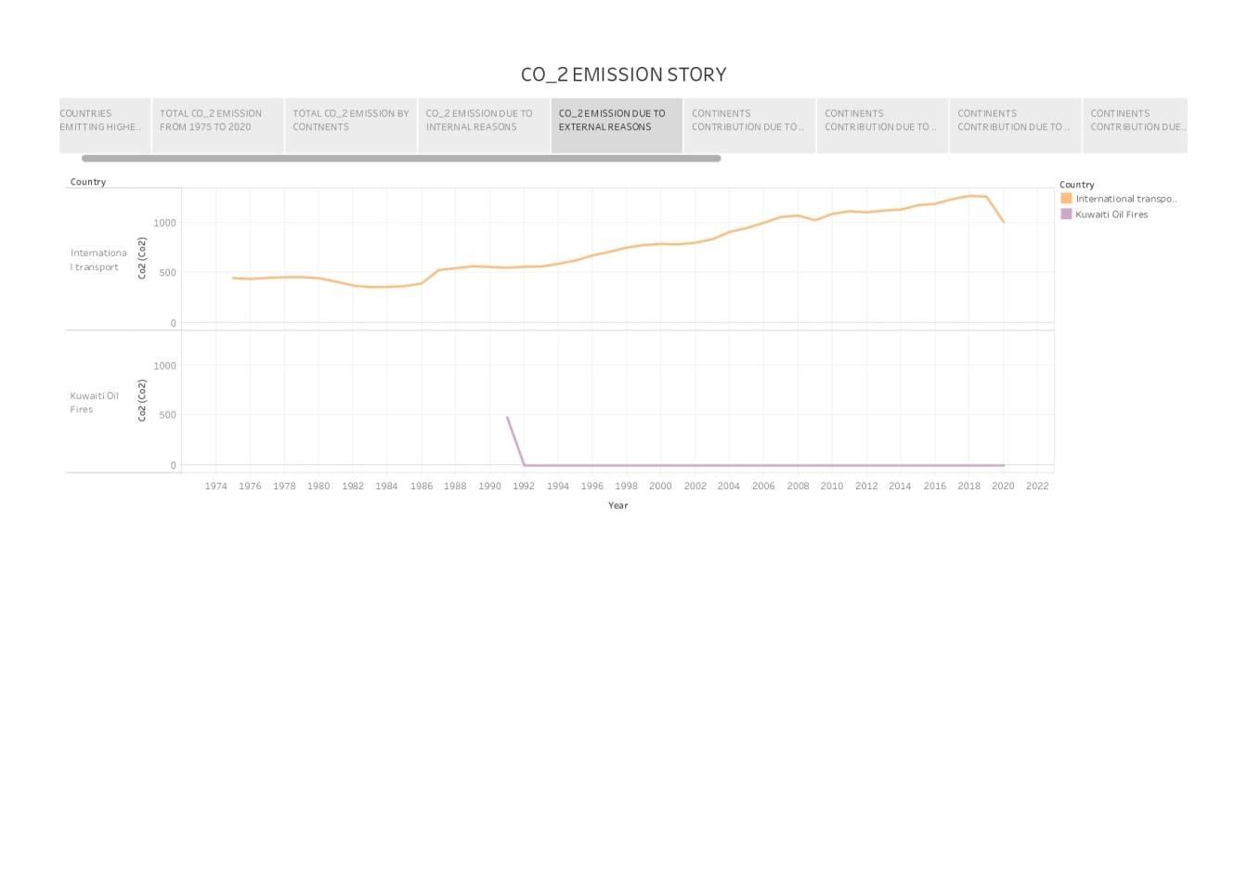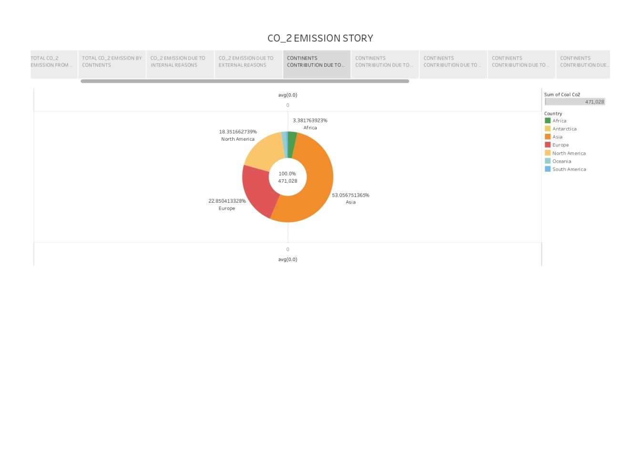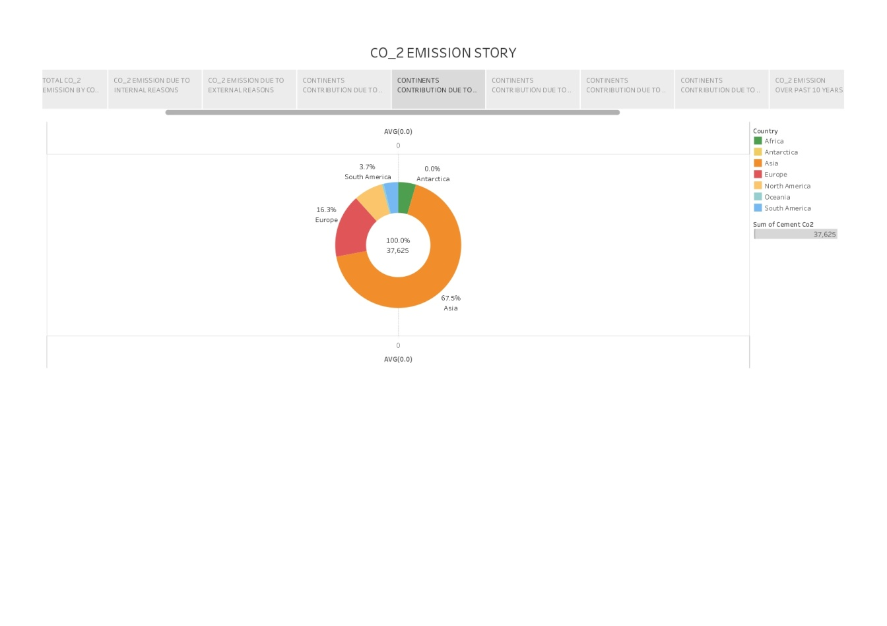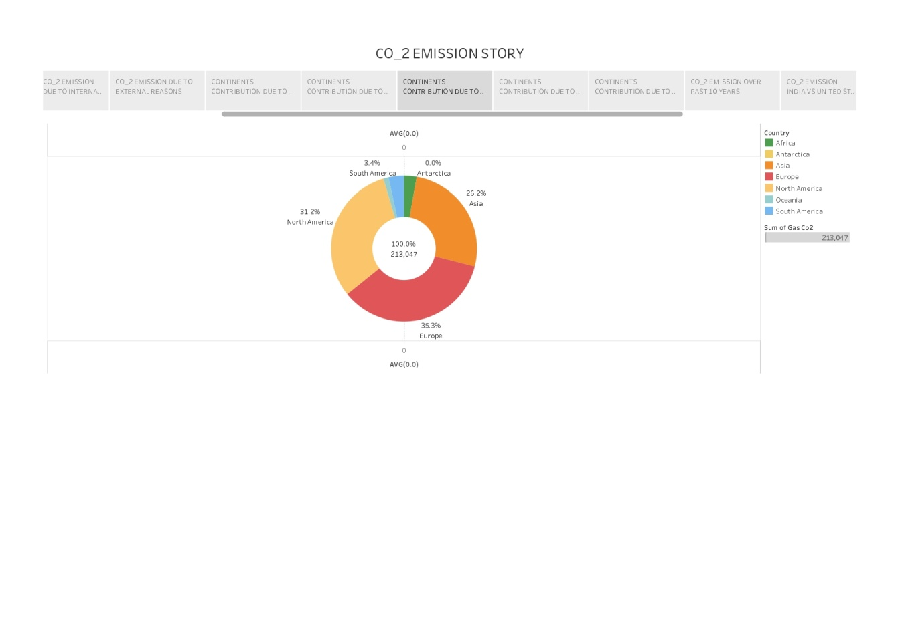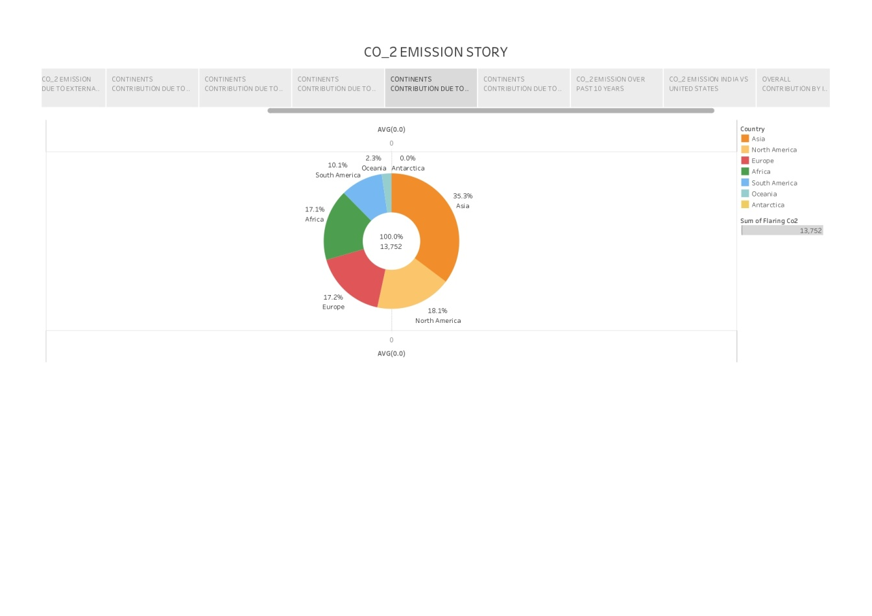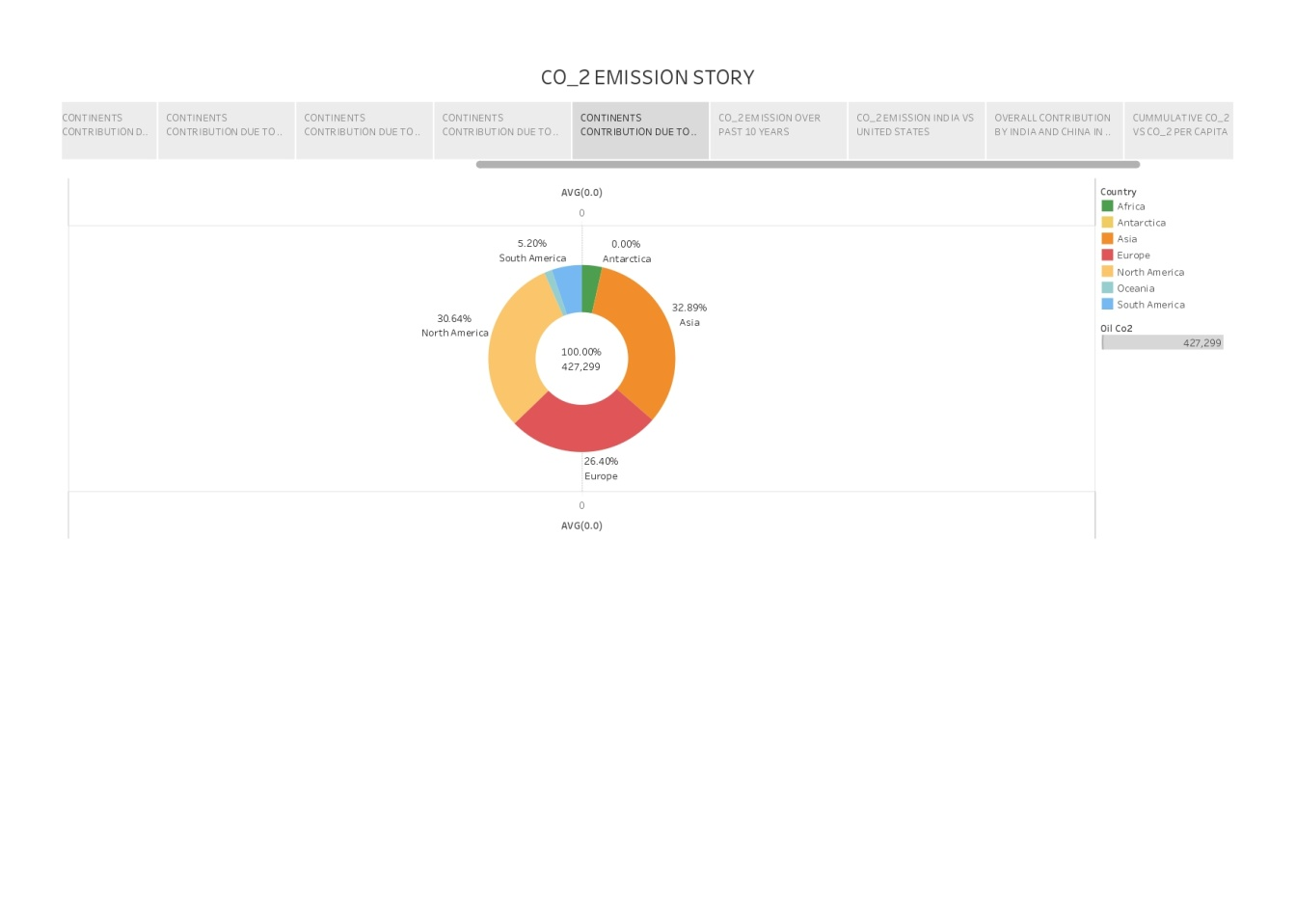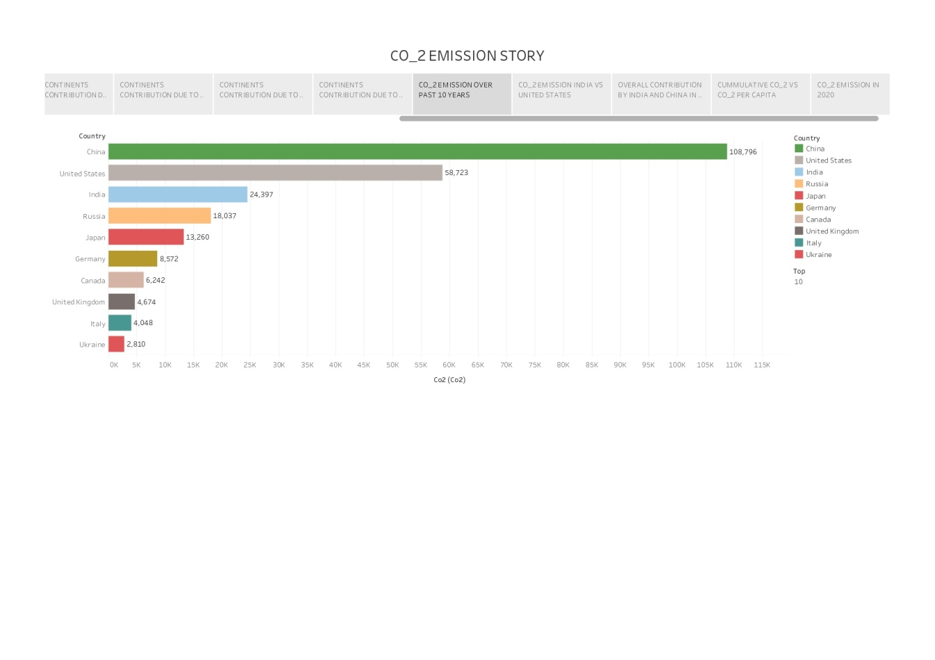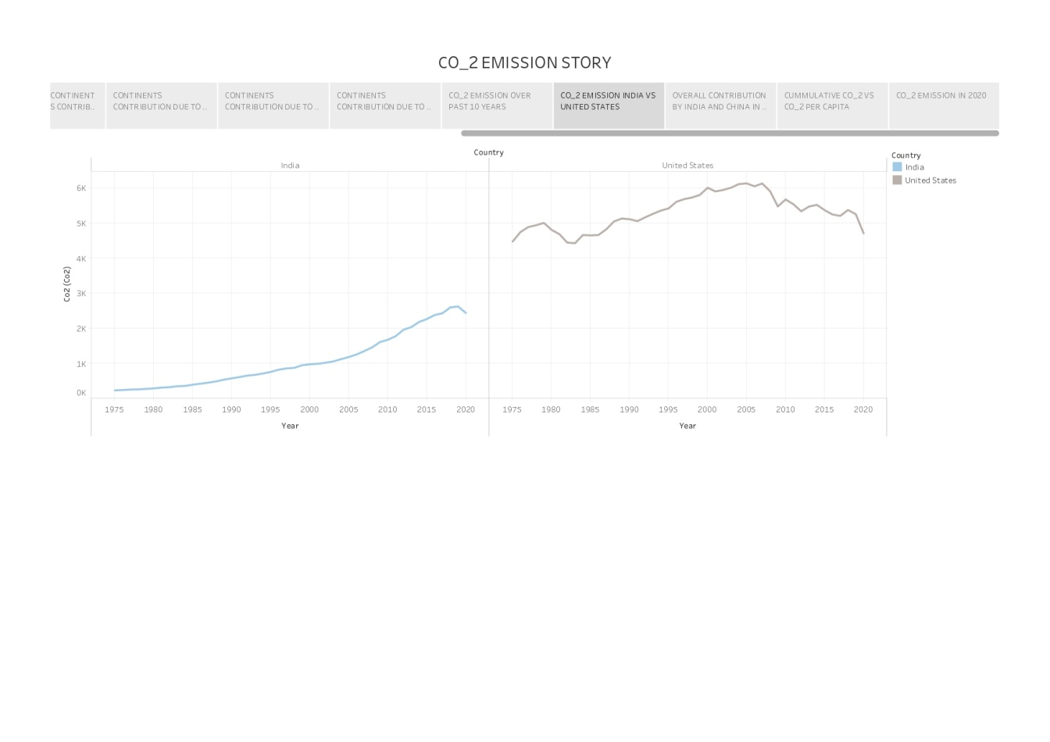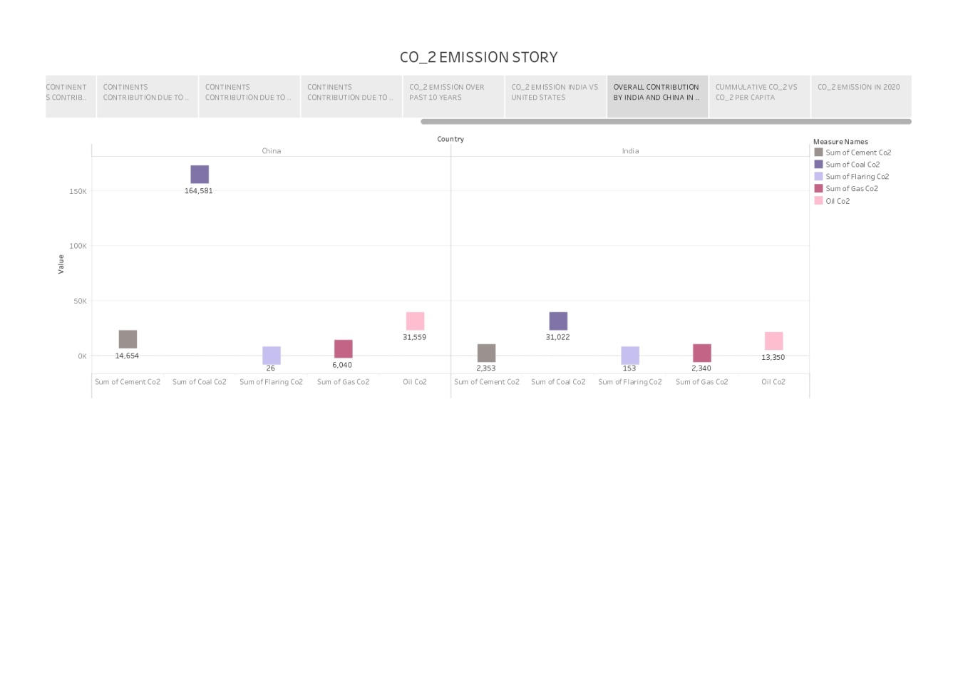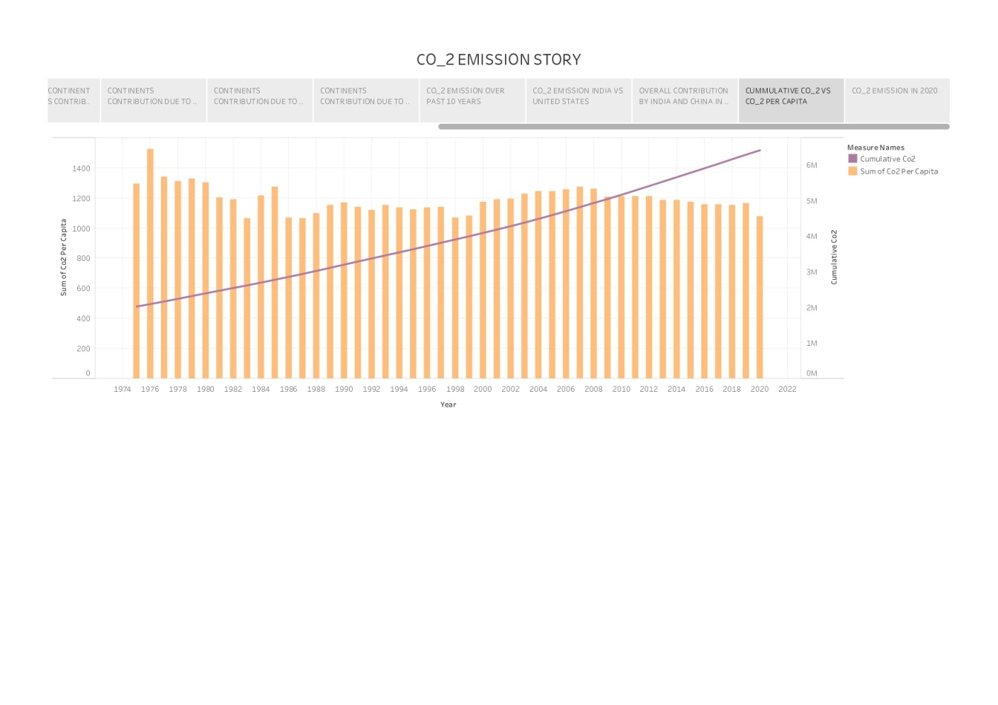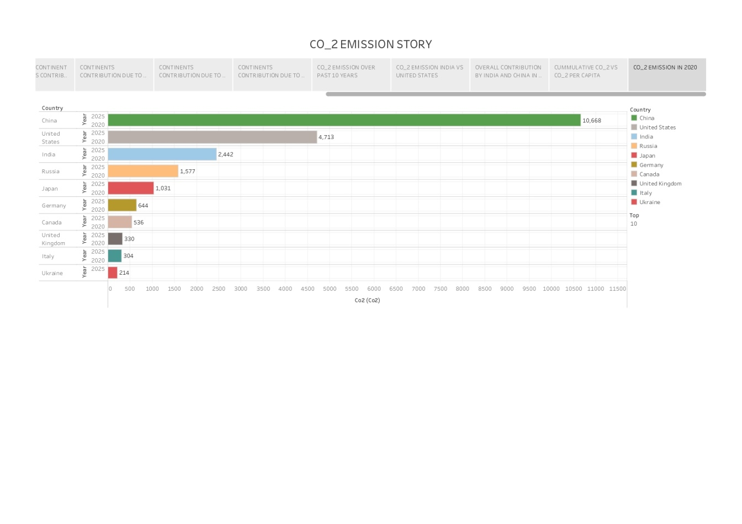

**WEB INTEGRATION: DASHBOARD AND STORY EMBEDED WITH UI WITH FLASK**

**Dashboard**

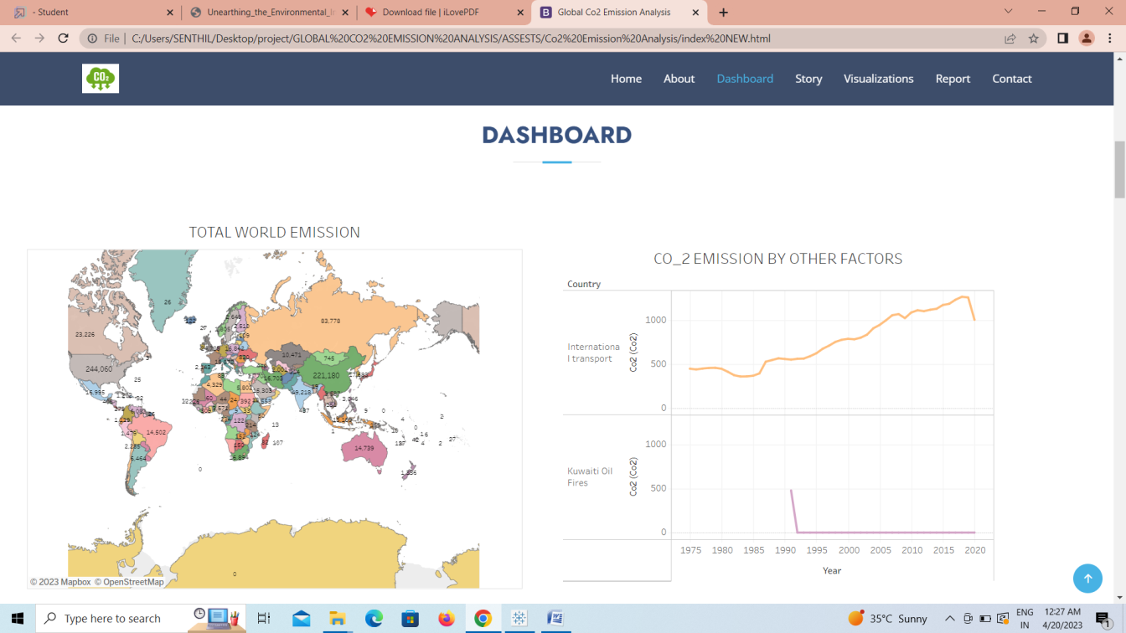

**Story**

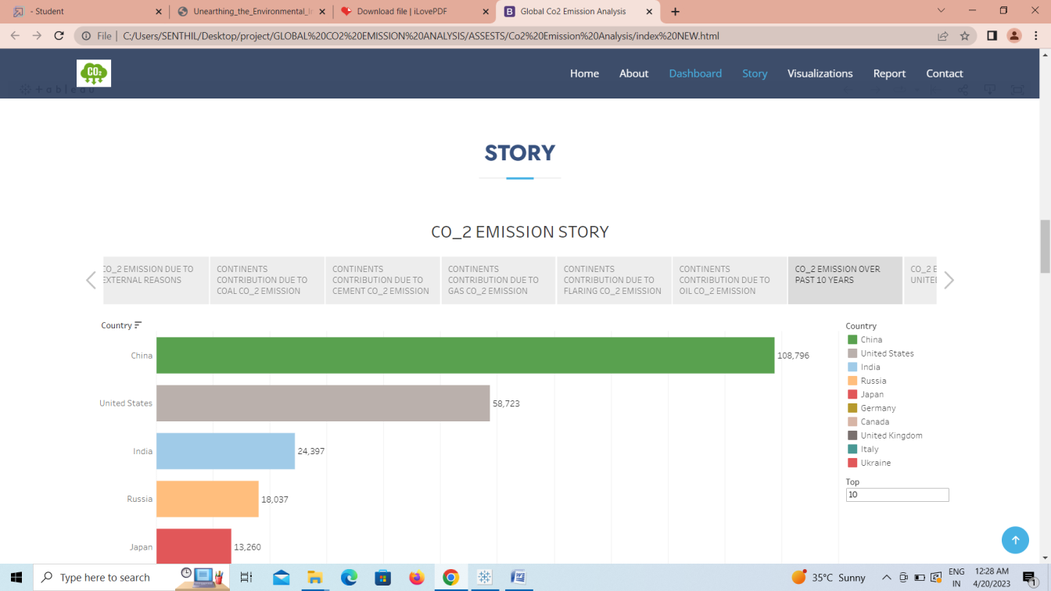

**4 ADVANTAGES AND DISADVANTAGES**

By this proposed solution we can overview a detailed data on global CO2 emission analysis. This project gives the clear idea on unique data visualization or graphs on a certain topic, the list of sheets are

* TOTAL WORLD EMISSION
* TOP EMITTING COUNTRIES
* TOTAL CO_2 EMISSION OVER TIME
* CO2 EMISSION INDIA VS UNITED STATES
* TOTAL EMISSION BY CONTINENTS
* CO_2 EMISSION PER CAPITA
* CO2 EMISSION BY INTERNAL FACTORS
* EMISSION RATE BY INTERNAL FACTORS
* DONUT CHART FOR COAL CO_2
* DONUT CHART FOR CEMENT CO2 EMISSION
* DONUT CHART FOR GAS CO2
* DONUT CHART FOR FLARING CO2 EMISSION
* DONUT CHART FOR OIL CO2 EMISSION
* CO2 EMISSION OVER PAST 10 YEARS
* OVERALL CONTRIBUTION BY INDIA IN CO2 EMISSION
* CONTINENT WISE CONTRIBUTION BY INTERNAL FACTORS
* CO2 EMISSION FROM 1990 TO 2020 BASED ON INTERNAL FACTORS
* CUMMULATIVE CO2 AND CO2 PER CAPITA OVER YEARS
* CO2 EMISSION IN 2020
* CHINA VS INDIA INTERNAL FACTORS
* OVERALL CONTRIBUTION BY CHINA IN CO2 EMISSION

**ADVANTAGES**

* Analyzing CO2 emissions has several advantages, including identifying excessive energy usage or inefficiencies in a company's processes.
* Reducing CO2 emissions can also lead to increased efficiency and cost-effectiveness.
* Additionally, reducing CO2 emissions can have environmental benefits, such as reducing greenhouse gas emissions and air pollution.
* Quantifying the emissions and health benefits of reducing CO2 emissions can help to better understand the impact of these reductions.
* However, some arguments against reducing CO2 emissions exist, and traditional science has advanced by comparing observations or experiments with theoretical.

**DISADVANTAGE**

* The disadvantage of CO2 emission analysis is that it may not be adequate to successfully deal with climate change.
* Additionally, quantifying climate benefits is complex and requires a comprehensive life-cycle assessment as well as understanding of market dynamics.
* However, reducing CO2 emissions can have economic co-benefits that outweigh the cost of mitigation for most big emitters.
* The transportation sector is the largest contributor of CO2 emissions, and this conducts analyses and reports for setting CO2 emissions standards for cars and trucks.
* The social cost of carbon is used in benefit-cost analysis to quantify the dollar-value of a policy's effect on climate change due to changes in greenhouse gas emissions.

**5 APPLICATIONS**

* CO2 emission analysis can be applied in various ways. One application is to use CO2 in the production of fuels, chemicals, and building materials, which can support climate goals where the application is scalable, uses low-carbon energy, and displaces a product with higher life-cycle emissions.
* Another application is to use machine learning to analyze CO2 emissions.
* CO2 emissions analysis is also important for understanding global greenhouse gas emissions and their sources, such as fossil fuel use and human-induced impacts on forestry and land use.
* Carbon footprint analysis is another way to analyze CO2 emissions, which should determine the exclusive global amount of direct and indirect emissions.
* Finally, carbon dioxide emissions reduction can be achieved through the substitution of biofuels for fossil fuels

**6 CONCLUSIONS**

* CO2 removal can contribute to a reduction of CO2 emissions, but further research and development is needed.
* Jurisdictions should analyze how carbon signals affect potential emissions reductions in the power sector.
* CO2 capture and storage is technologically feasible and could play a significant role in reducing greenhouse gas emissions.
* The equilibrium climate sensitivity is only one parameter affecting the social cost of carbon.
* Carbon emissions efficiency can be divided into industrial carbon emission efficiency and other categories.
* CO2 removal can contribute substantially to a reduction of CO2 emissions, but further research and development is needed.
* Fossil fuel use is the primary source of CO2 emissions, and it can also be emitted from direct human-induced impacts on forestry and other land use.
* Global CO2 emissions declined by 5.8% in 2020, which is the largest ever decline and almost five times greater than the 2009 decline that followed the global financial crisis.
* CO2 emissions from energy combustion grew by around 1.3% or 423 mt in 2022, while CO2 emissions from industrial processes declined by 102 mt. Emissions growth in 2022 was below global GDP growth (+3.2%), reverting to a decades-long trend of decoupling emissions and economic growth that was broken in 2021.

**FUTURE SCOPE**

The future scope of CO2 analysis is promising, as carbon capture, utilization, and storage technologies are expected to play a significant role in reducing greenhouse gas emissions and achieving climate and energy goals. Materials' applications for CO2 capture are also being researched. While carbon capture and storage technology is not yet economically feasible, it has the potential to help deliver net-zero targets and reduce the impact of climate change.

**APPENDIX**

* [**Tableau public link for Lakshmi Priya**](https://public.tableau.com/app/profile/lakshmi.priya.a7281)
* **SOURCE CODE FOR WEB INTEGRATION**